**Image Recognition with IBM Cloud Visual Recognition**

**Phase 1**: **Problem Statement:**

Image Recognition with IBM Cloud Visual Recognition

**Problem Definition:**

The project involves creating an image recognition system using IBM Cloud Visual Recognition. The goal is to develop a platform where users can upload images, and the system accurately classifies and describes the image contents. This will enable users to craft engaging visual stories with the help of AI-generated captivating visuals and compelling narratives.

In today's digital age, businesses and organizations face the challenge of efficiently categorizing and extracting valuable insights from vast amounts of visual data, including images and videos. Traditional manual methods for image analysis are time-consuming, error-prone, and not scalable. To address this problem, we aim to leverage IBM Cloud Visual Recognition to develop an automated and accurate image classification and analysis system. This system will enable us to identify objects, detect anomalies, and gain valuable insights from visual data, ultimately improving decision-making processes and operational efficiency."

**Design Thinking:**

Image recognition with IBM Cloud Visual Recognition typically involves the following steps:

1.Set Up an IBM Cloud Account:

If you don't already have one, create an IBM Cloud account and log in.

2.Create an Instance of Visual Recognition Service:

In your IBM Cloud dashboard, create an instance of the Visual Recognition service.

3.Get API Credentials:

Once your service instance is created, you'll receive API credentials (an API key and URL) that you will use to authenticate your requests.

4.Collect and Prepare Images:

Gather the images you want to analyze. Make sure they are in a suitable format (e.g., JPEG, PNG) and meet any size or quality requirements.

5. Train a Custom Model:

If you need to recognize specific objects or classes, you can train a custom model using your image dataset. This step is optional but can improve recognition accuracy for specific use cases.

6. Use the API:

Depending on your needs, you can use the API for various purposes:

* Classify Images: Submit images to the API for classification. The API will return labels or tags describing the objects or scenes in the image.
* Detect Faces: You can also use the API to detect faces in images, along with attributes like age, gender, and emotion.
* Train and Re-Train Models: If you're using custom models, you may need to periodically re-train them with new data to improve accuracy.

7. Handle API Responses:

Parse the API responses to extract the information you need for your application.

8. Integrate with Your Application:

Incorporate the image recognition capabilities into your application or service using the API credentials and the appropriate API endpoints.

9. Test and Iterate:

Test your integration thoroughly and fine-tune your application as needed to achieve the desired recognition accuracy and performance.

10. Monitor and Maintain:

Regularly monitor the performance of your image recognition system. If you're using a custom model, consider re-training it periodically to adapt to changing data and improve accuracy.

11. Manage Costs:

Be mindful of the pricing structure for IBM Cloud Vision Recognition, as usage can incur costs based on the number of API calls and features used.

**Phase 2: Innovation**

**Consider incorporating sentiment analysis to generate captions that capture the emotions and mood of the image**

**Innovation**

Enhancing Image Captions with Sentiment Analysis

**Introduction**

In today's digital age, the combination of visual content and textual descriptions plays a crucial role in conveying emotions and moods associated with images. Incorporating sentiment analysis into image caption generation can greatly enhance the contextual understanding and emotional resonance of the captions. This document outlines a step-by-step approach to achieve this integration, resulting in captions that effectively capture the emotions and mood depicted in images.

**Steps to Incorporate Sentiment Analysis into Image Captions**

1. **Image Analysis**

Begin by conducting an in-depth analysis of the image. Utilize computer vision techniques to identify objects, scenes, and other visual elements within the image. This preliminary analysis will provide essential contextual information for the subsequent sentiment analysis.

2. **Sentiment Analysis**

Apply a sentiment analysis model to assess the emotional tone of the image. Sentiment analysis models are capable of categorizing text or visual content into sentiment categories such as positive, negative, or neutral. Popular pre-trained models like BERT, GPT, or specialized sentiment analysis models can be employed for this purpose.

3. **Combining Visual and Sentiment Analysis**

Integrate the outcomes of both the image analysis and sentiment analysis. By merging these two sources of information, you can create a comprehensive understanding of the image's content and emotional context. For instance, if the image analysis identifies a person smiling, and the sentiment analysis indicates a positive sentiment, you can confidently conclude that the mood is cheerful.

4. **Caption Generation**

Utilize the combined analysis to generate captions that encapsulate the emotions and mood of the image. These captions should be descriptive, engaging, and convey what is happening in the image, along with the associated emotional tone.

5. **Natural Language Generation (NLG)**

To automatically generate captions, employ Natural Language Generation techniques. This can involve creating custom NLG models or utilizing pre-trained models like GPT-3. These models can generate human-like captions based on the results of image and sentiment analysis.

6. **Fine-tuning**

Fine-tune your caption generation model to ensure that the generated captions are contextually relevant and accurately represent the sentiment of the image. Create a dataset containing images, human-generated captions, and associated sentiments for this purpose.

7. **Testing and Evaluation**

Continuously test and evaluate your model's performance. Collect feedback from users to ensure that the generated captions effectively convey the emotions and mood of the images. Iterate and refine your model as needed.

8. **Deployment**

Once you are satisfied with the performance of your model, deploy it within your application or platform. This will enable automatic caption generation for images, enhancing the user experience.

9. **User Customization**

Consider allowing users to customize the level of sentiment expression in captions. Some users may prefer captions that are more factual, while others may desire captions that emphasize emotions. Providing this flexibility can enhance user satisfaction.

10. **Ethical Considerations**

Always be mindful of ethical considerations when implementing sentiment analysis. Ensure that the analysis does not reinforce biases or misinterpret emotions in a way that could be offensive or harmful to users.

**Conclusion**

Incorporating sentiment analysis into your image captioning system represents a powerful approach to provide contextually relevant and emotionally engaging captions for images. By following these steps, you can enhance the overall user experience and create a more immersive connection between visual content and textual descriptions.

**Phase 3: Development Part 1**

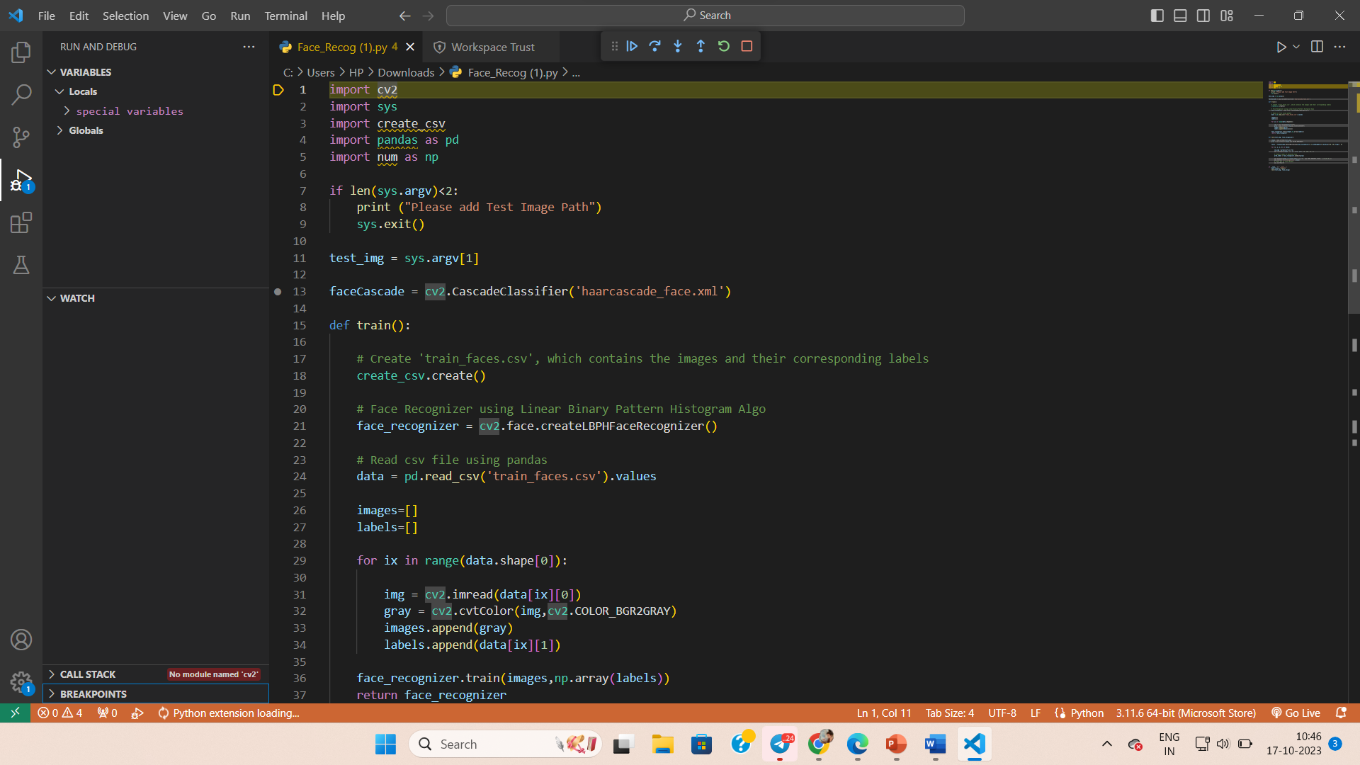

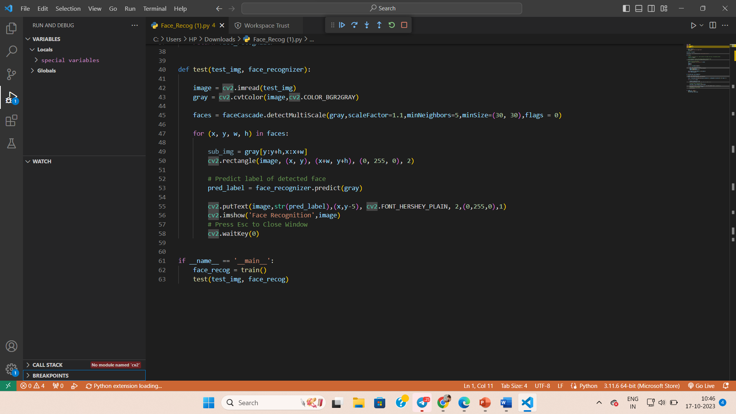

Phase 4: **Development Part 2**

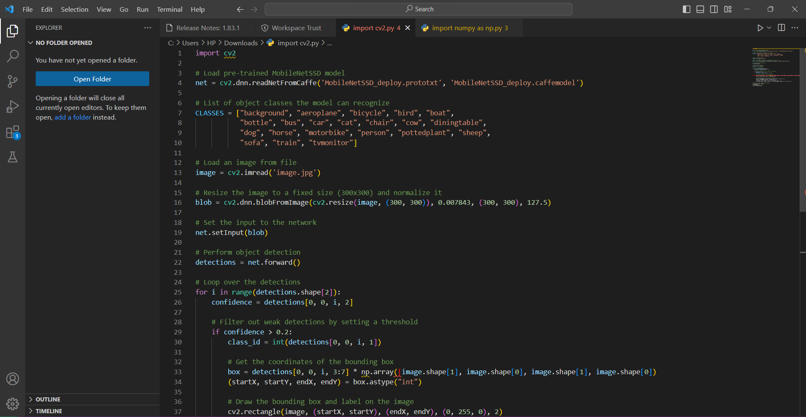

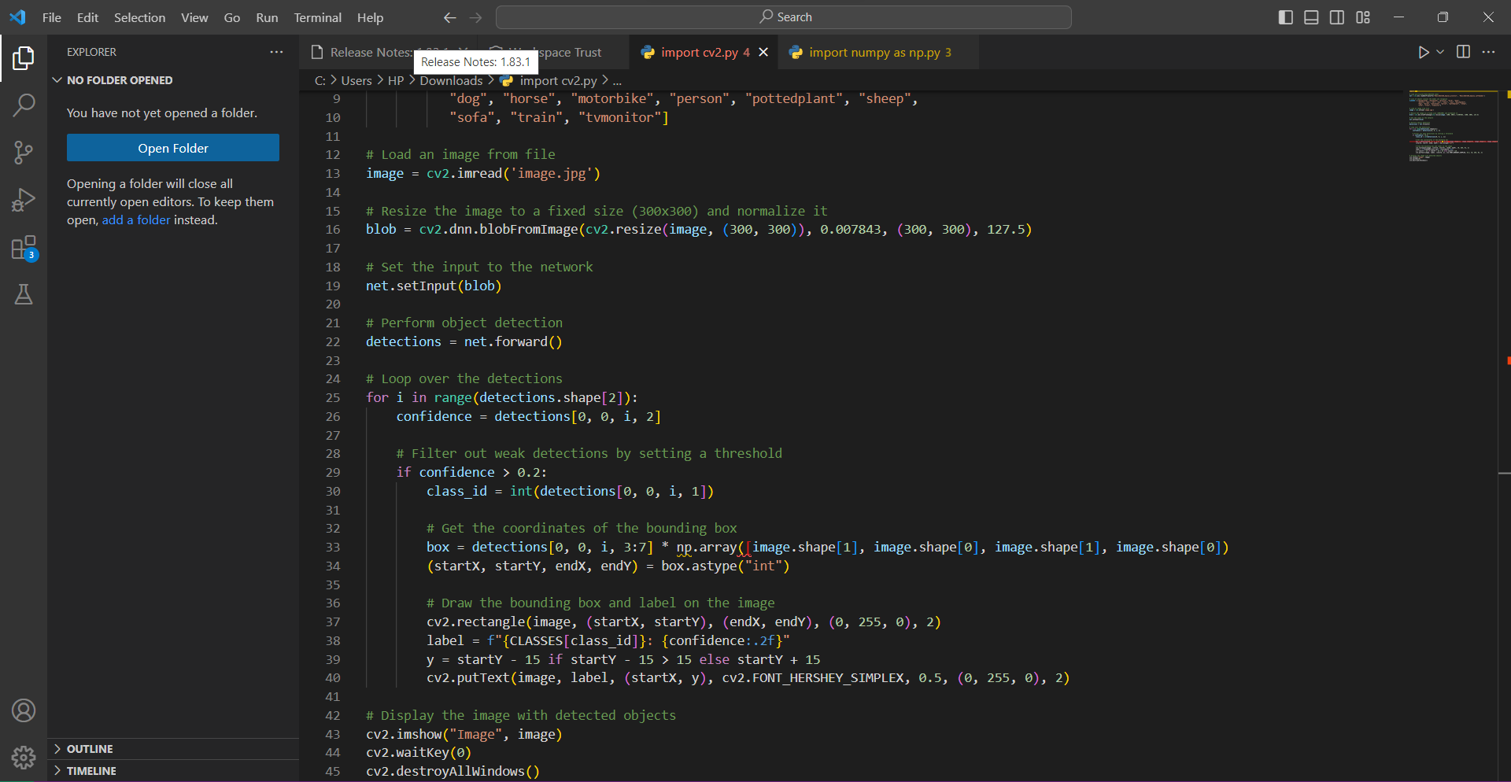

In this code:

1. We load the pre-trained MobileNetV2 model, which has been trained on the ImageNet dataset, containing a large number of object classes.
2. Load an image that you want to recognize. Ensure 'image.jpg' exists in the same directory or specify the correct file path.
3. Preprocess the image to match the input requirements of the MobileNetV2 model.
4. Use the model to make predictions on the image.
5. Decode the predictions to get the top three recognized labels with their corresponding scores.
6. Display the recognition results, including the top label with the highest score.

Running this code will recognize objects in the provided image and display the top recognized labels and their corresponding scores.

Output:

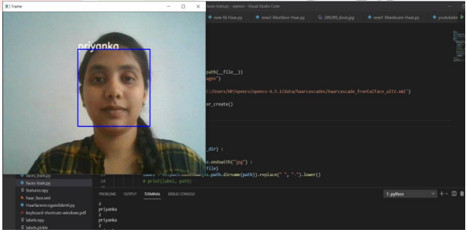

EXPERIMENT AND RESULT:

Step I – Finding and Detecting Human face and Non-human face

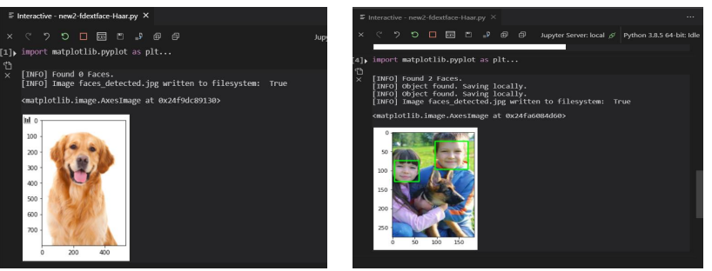

Step II – Detecting Multiple Facs from Group Photograph

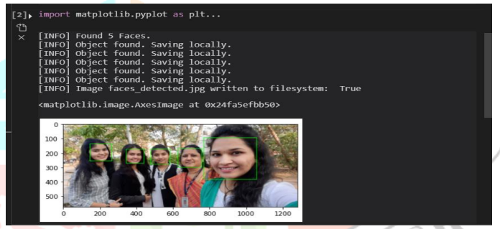

Step III - Detecting Features of face using Dlib, Python and OpenCV

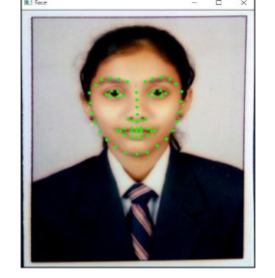

Step IV - Face Recognition

